Guidelines for Term Project Implementation in SAP
- SAP Environment for Implementation
Server: tirane
Client: 330
SAPGUI configuration:
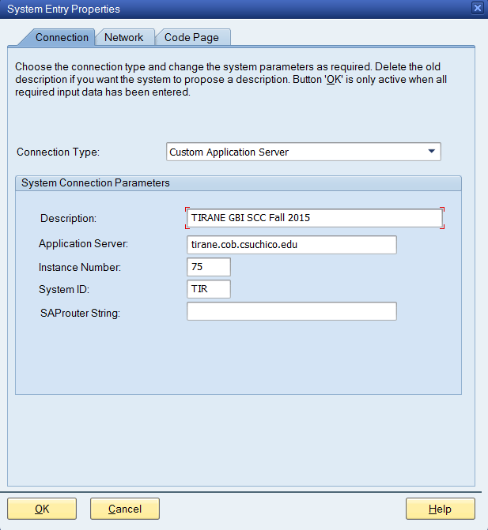

Userid: gbi-0## Initial password: SAP4US

Team 1 (Diego’s Team): use US08 organization structure,
Team 2 (Sigfredo’s team): use US09 or US06 organization structure,
Team 3 (Francesca’s Team): use US07 organization structure,
Team 4 (Pierre’s Team): use US02 organization structure,
Team 5 (Andrew’s Team): use US17 organization structure,
Team 6 (Richard’s Team): use US03 or US04 organization structure, and
Team 7 (Yidong’s Team): use US16 organization structure,

Name | Uersid | Password
Martinez,Diego Hernan | gbi-008 | 123456
Fan,Yuhan | gbi-020 | 123456
Reyes,Evis | gbi-011 | 123456
Suarez,Rolando | gbi-013 | 123456
Espinoza Acosta,Sigfredo Alejandro | gbi-006 | 123456
Ahmad,Mohamed Nathmi | gbi021 | 123456
Deonarinesingh,Parvesh | gbi-005 | 123456
Poosti,Mehrnoosh | gbi-009 | 123456
Lucia,Francesca | gbi-007 | 123456
Duran Arboleda,Edith Estefania | gbi-022 | 123456
Quezada Rivera,Rosirys Elena | gbi-010 | 123456
Velez Gonzalez,William-Jose | gbi-014 | 123456
Samson,Pierre- Richard | gbi-012 | 123456
Antonio,Joao R | gbi-001 | 123456
Beatty Jr,John Lowell | gbi-002 | 123456
Escobar,Isabel | gbi-023 | 123456
Decker,Andrew Phillip | gbi-017 | 123456
Moacys, Paulo | gbi-024 | 123456
Li, Xue | gbi-025 | 123456
Xu, Huibingjue | gbi-026 | 123456
Castillo,Richard Alexander | gb-004 | 123456
Bellini,Alejandro | gb-003 | 123456
He,Jiamu | gbi-018 | 123456
Hegazy,Khaled Ahmed Mohamed Hasan | gbi-027 | 123456
Zhong,Yidong | gbi-016 | 123456
Gu,Xingshuo | gbi-028 | 123456
He,Linman | gbi-029 | 123456
Yang,Yuping | gbi-030 | 123456

- Changes in Enterprise Organization Structure

Choose one company code listed above as your platform to implement your project.
Show your enterprise systems structure (company code, fiscal year variant, control area, credit area, plant codes, shipping points, storage locations, sales org. purchasing org. , purchase group, and standard hierarchy for cost centers).
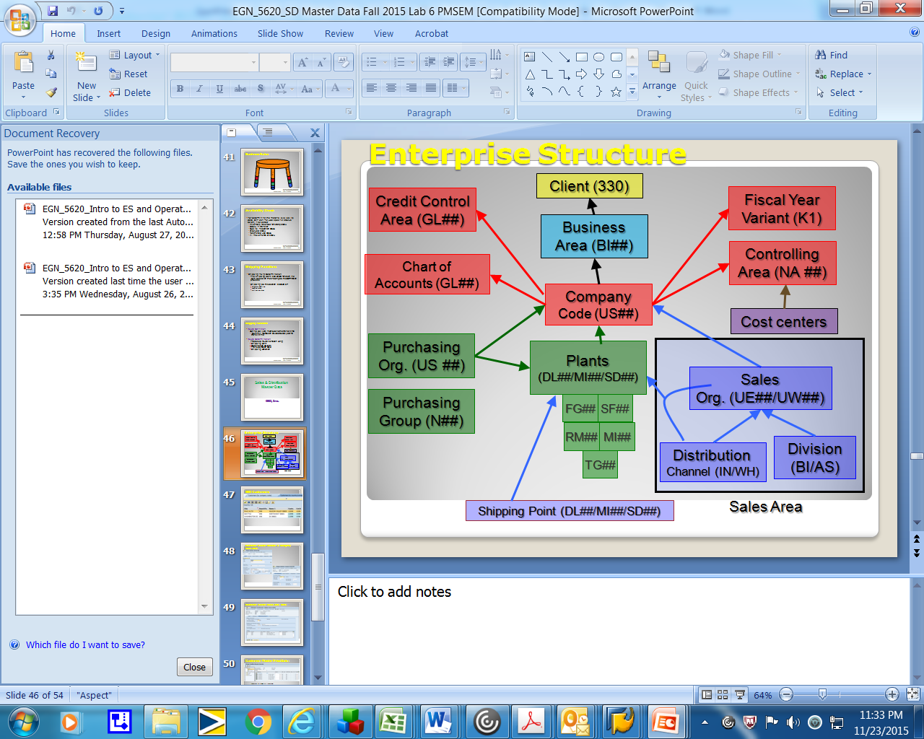
- Change the name of your company code (T-code: SPRO)
- Change the plant name (T-code: SPRO)
- Change the sales organization name (T-code: SPRO)
- Change your purchase organization name (T-code: SPRO)

3. New Master Data for Materials Management
- Create two new finished goods (T-code: MMF1).
- Create relative raw materials. (T-code: MMR1).
- Create two new vendors “0## Chen and Associates, Inc.” and “0## ABC and Associates, Inc.” (T-code: XK01).
- Create new info records for new raw materials. (T-code: ME11).
- Create new source lists for your new raw materials and new vendor. (T-code: ME01).

4. New Master Data for Sales Management
- Create two new customers (0## Shen and Associates, Inc. for WH) and (0## King and Associates, Inc. for WH). (T-code: XD01)
- Create pricing conditions (T-code: VK31)
- Setup credit limit for your new customer. (T-code: FD32)

5. New Master Data for Production Management
- Modify labor activity price. (T-code: KP26)
- Create your work centers for production. (T-code: CR01)
- Create BOMs for two new finished products. (T-code: CS01)
- Create routings for two new finished goods. (T-code: CA01) .
- Create a new product group. (T-code: MC84)

6. Operation Activities
- After implementation, send an email to your instructor to introduce two new finished products with prices in WH, credit limit, and delivery date.
- Create sales orders for your new finished products. (T-code: VA01)
- Run MPS/MRP to generate purchase requisitions and planned orders. (T-code: MD41). You should run twice for each of your new finished product.
- Create purchase order for required raw materials to your new vendor. (T-code: ME21N)
- Make goods receipt for PO. (T-code: MIGO)
- Post invoice receipt for your new vendor. (T-code: MIRO)
- Post payment to your new vendor. (T-code: F-53)
- Convert planned orders to production order. (T-code: MD04)
- Make goods issue to production order. (T-code: MB1A)
- Confirm production completion. (T-code: CO15)
- Make goods receipt of finished goods from production order. (T-code: MB31)
- Make production order costs settlement. (T-code: KO88)
- Create delivery notes. (T-code: VL01N)
- Ship materials (make goods issue). (T-code: VL02N)
- Bill your new customer. (T-code: VF01)
- Receive payment. (T-code: F-28)

Note:
- For the final written project report, take screen shots to show each implementation and operation activity.
- A list of T-codes used during the implementation and operation (separated them by each of the 3 modules)

